# //webstorm ES6设置

## 1.Settings-Languages&Frameworks-JavaScript-ECMAScript6

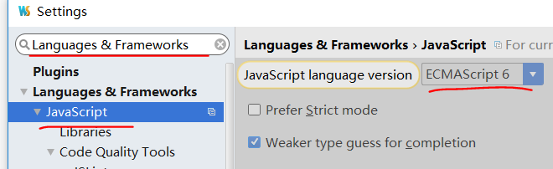

## 2.npm install -g babel

## 3.Settings-Tools-File watchers-点击右侧“+”--设置Babel

